Test Case: tc002_SPX_Dev5_Crear_Requisicion_Spot_Tipo_Cobro_Project
Step 1 - Enter username and password and click to button Enter: Credentials Entered
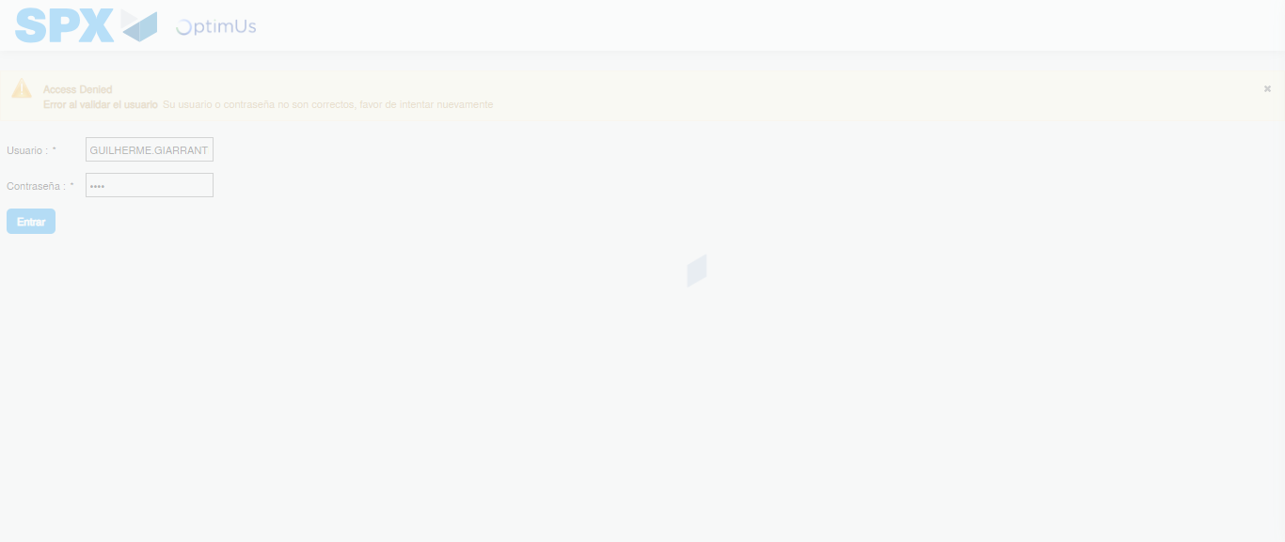Image file-name: QC_Testing-tc002_SPX_Dev5_Crear_Requisicion_Spot_Tipo_Cobro_Project-1784308885299

Step 2 - Select to UEN and Access to Spot Buy Requisitions : UEN Correctly selected and Correct access
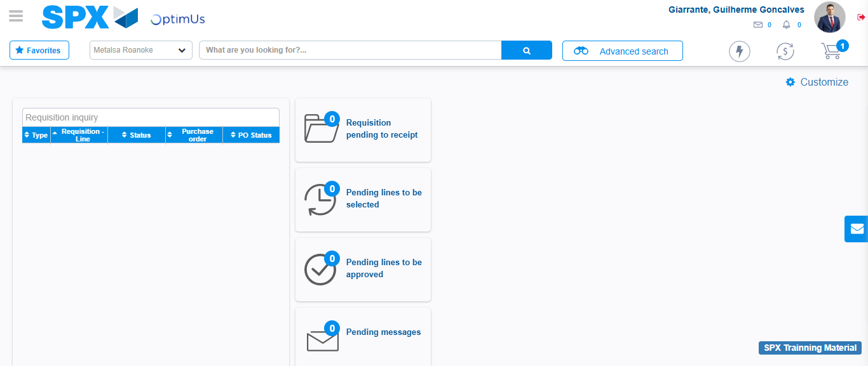Image file-name: QC_Testing-tc002_SPX_Dev5_Crear_Requisicion_Spot_Tipo_Cobro_Project-1784308960487

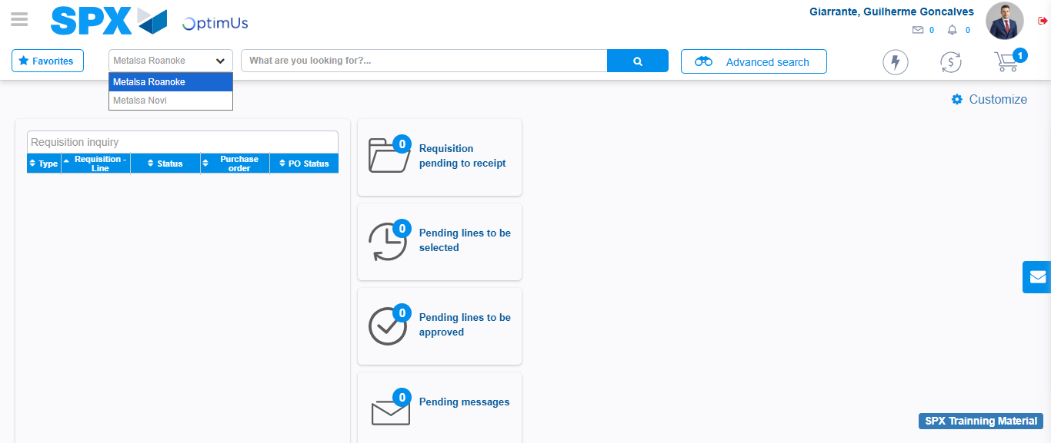Image file-name: QC_Testing-tc002_SPX_Dev5_Crear_Requisicion_Spot_Tipo_Cobro_Project-1784308963155

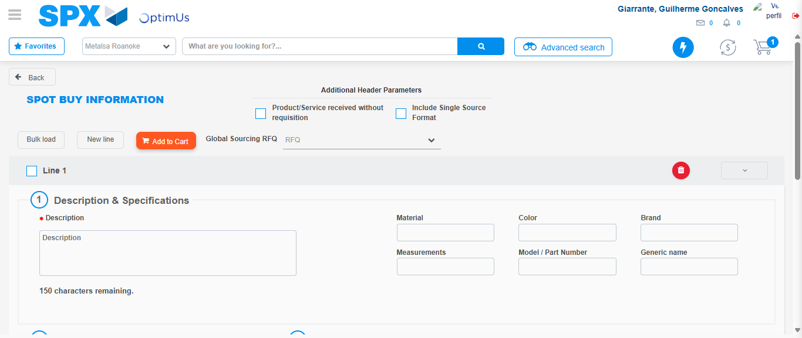Image file-name: QC_Testing-tc002_SPX_Dev5_Crear_Requisicion_Spot_Tipo_Cobro_Project-1784308990076

Step 3 - Data Capture Spot Buy Requisition: Data captured correctly
Image file-name: QC_Testing-tc002_SPX_Dev5_Crear_Requisicion_Spot_Tipo_Cobro_Project-1784308990412

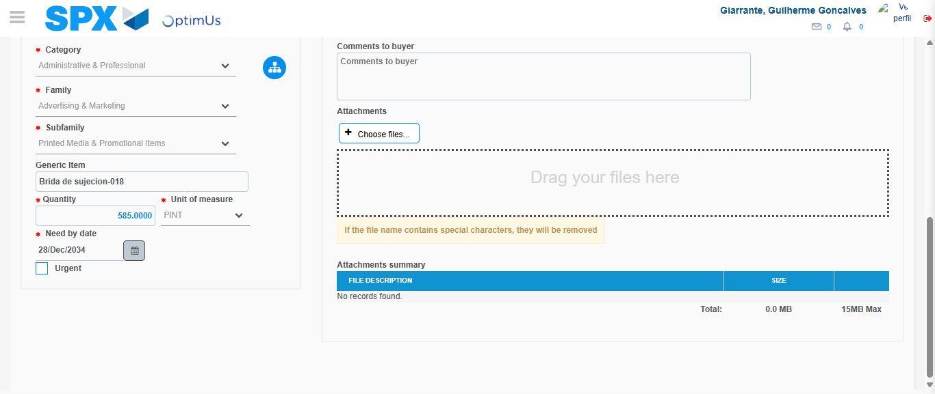Image file-name: QC_Testing-tc002_SPX_Dev5_Crear_Requisicion_Spot_Tipo_Cobro_Project-1784309003899

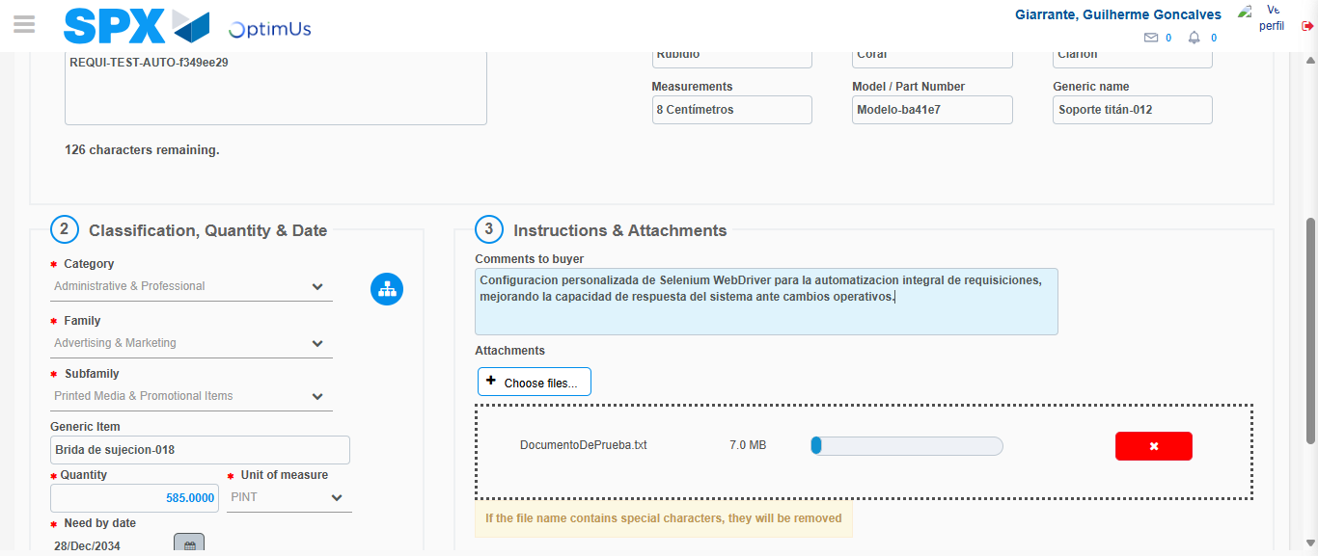Image file-name: QC_Testing-tc002_SPX_Dev5_Crear_Requisicion_Spot_Tipo_Cobro_Project-1784309005000

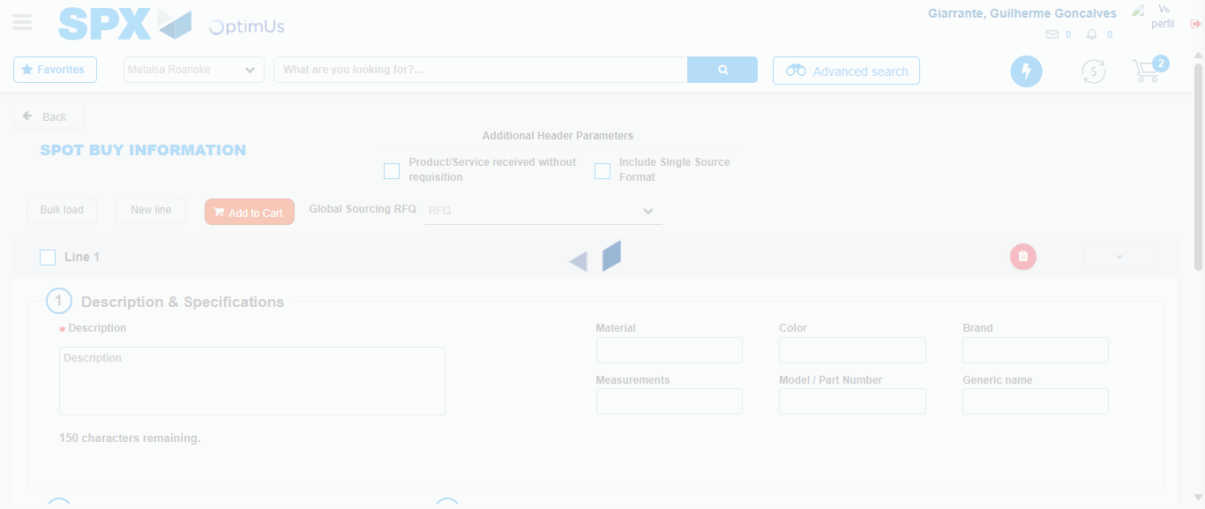Image file-name: QC_Testing-tc002_SPX_Dev5_Crear_Requisicion_Spot_Tipo_Cobro_Project-1784309011440

Step 7 - Return to Main Page SPX : Return to Main Page SPX
Image file-name: QC_Testing-tc002_SPX_Dev5_Crear_Requisicion_Spot_Tipo_Cobro_Project-1784308960487

Image file-name: QC_Testing-tc002_SPX_Dev5_Crear_Requisicion_Spot_Tipo_Cobro_Project-1784308963155

Image file-name: QC_Testing-tc002_SPX_Dev5_Crear_Requisicion_Spot_Tipo_Cobro_Project-1784308990076

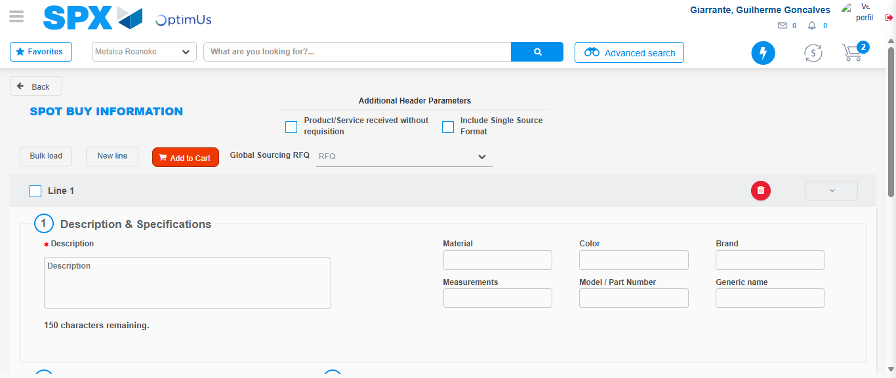Image file-name: QC_Testing-tc002_SPX_Dev5_Crear_Requisicion_Spot_Tipo_Cobro_Project-1784309013725

Image file-name: QC_Testing-tc002_SPX_Dev5_Crear_Requisicion_Spot_Tipo_Cobro_Project-1784309013920

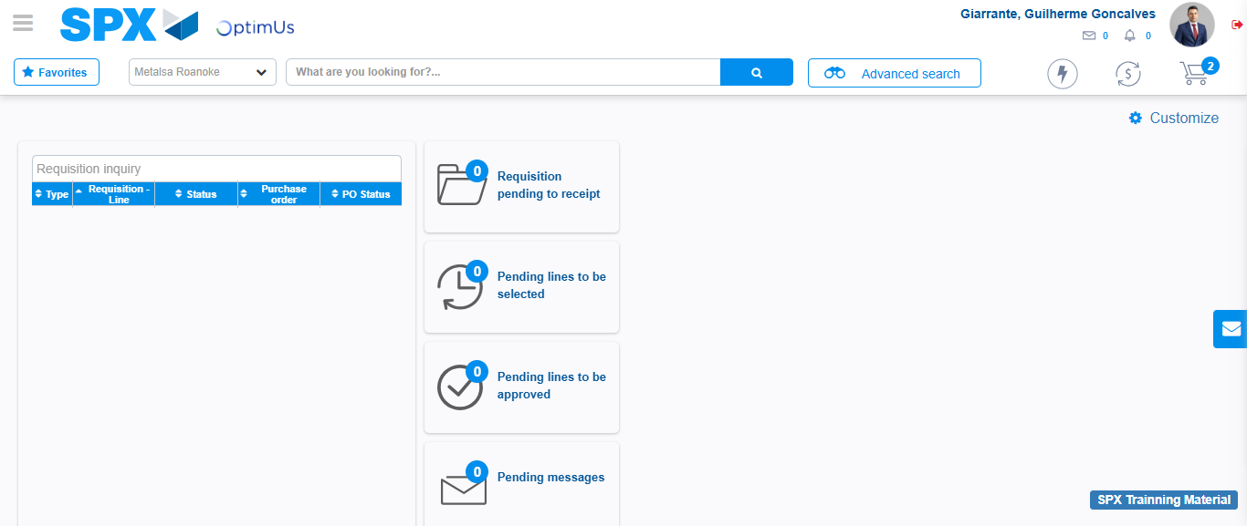Image file-name: QC_Testing-tc002_SPX_Dev5_Crear_Requisicion_Spot_Tipo_Cobro_Project-1784309035183

Step 8 - Log Out : Log Out SPX
Image file-name: QC_Testing-tc002_SPX_Dev5_Crear_Requisicion_Spot_Tipo_Cobro_Project-1784309035424

